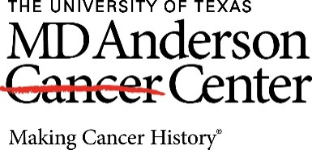

Many people are unaware of tax-exempt planning strategies that help them leave a charitable legacy, reduce taxes and maximize benefits from their assets. By educating people on the benefits of charitable planning, The University of Texas MD Anderson Professional Advisors Council (PAC) members hope to inspire a new community of philanthropists who are able to address their needs for financial security and family legacy while investing in programs that advance our goal of making cancer history®.

MD Anderson PAC members are estate, tax, and financial planning professionals who share MD Anderson’s commitment to eliminate cancer.

Expectations of PAC members

- Attend the annual MD Anderson PAC Luncheon if schedule and location permits.
- Have an interest in learning about MD Anderson’s cutting-edge research, cancer prevention, and patient support and education programs via email and optional events.
- Help share your knowledge of MD Anderson’s mission with your network, when appropriate.

Benefits of Membership

- Opportunity to attend the annual MD Anderson PAC Luncheon and other events.
- A personalized tour of our main campus, including a visit with a faculty member who specializes in an area of interest to you and your guests.
- Research updates and newsletters.
- The satisfaction of knowing that your efforts help build a new community of philanthropists who are helping one of the largest cancer centers in the world. One patient at a time, one discovery at a time, MD Anderson is truly Making Cancer History® like nowhere else.

To join the MD Anderson Professional Advisors Council today, complete the online form here.

